wSmart fertilizer spraying system using plant disease severity analysis
Abstract:
The Smart Fertilizer Spraying System with Plant Disease Severity Analysis is an automated agricultural robot designed to enhance crop management through precision farming. The system employs a Raspberry Pi equipped with a USB camera to capture plant images and analyze disease severity using advanced image processing techniques. Based on the detected severity levels, the system dynamically regulates fertilizer spraying duration through three dedicated nozzles, ensuring precise application and minimizing wastage. An Arduino microcontroller manages the operation of DC motors, water pumps, relays, and the robot chassis for efficient movement. Powered by a 12V battery and supported by a 9V solar panel, the system offers sustainable and energy-efficient operation. Bluetooth connectivity facilitates wireless monitoring and control. By combining disease detection with intelligent fertilizer management, this system reduces human intervention, optimizes resource utilization, and promotes eco-friendly farming practices.
Introduction:
The Smart Fertilizer Spraying System with Plant Disease Severity Analysis is an automated agricultural robot developed to improve crop management through precision farming. The system uses a Raspberry Pi integrated with a USB camera to capture plant images and analyze disease severity using advanced image processing techniques. Based on the detected severity levels, the system automatically controls the fertilizer spraying process by adjusting the spray duration through three dedicated nozzles, ensuring accurate application while minimizing fertilizer wastage. An Arduino microcontroller manages the robot’s movement and controls hardware components such as DC motors, water pumps, relays, and the chassis to enable efficient field navigation. The system is powered by a 12V battery supported by a 9V solar panel, providing sustainable and energy-efficient operation. Bluetooth connectivity allows wireless monitoring and control of the system. By integrating plant disease detection with intelligent fertilizer management, the proposed system reduces human intervention, optimizes resource utilization, and promotes eco-friendly and sustainable agricultural practices.

Literature Survey:
1. Plant Disease Detection System for Smart Agriculture
Indian economy relies on agriculture to a greater extent. In traditional agriculture, the farmers identify the crop diseases with the help of an expert either by direct visual inspection or by sending the diseased images to experts through online services. Also, continuous monitoring cannot be done manually. The main objective is to develop an android application which identifies and classifies three major diseases - Black horse riding, Brown spot and Bacterial leaf steak. In the plant disease detection system, image to be tested is acquired, pre-processed, segmented and classified based on the disease type. The classification is performed using probabilistic linear classifier called Naive Bayes. The application is developed using Android Studio and the programming language used for the development is java. This application identifies the plant disease based on pixel intensities, predicts the plant growth and sunlight condition if it is good or not. It suggests suitable fertilizers and pesticides depending on the disease type. The average accuracy of the developed application is about 80% and the implementation of this system reduces manpower and increases productivity.
2. Development of Smart Pesticide Spraying Robot
India is the farmland with a population of threefourths in agriculture. In accordance with the climate and other resources accessible to them, farmers will grow multiple plants in their field. But some technical abilities along with technological assistance are required to achieve high output and excellent quality. The management of food crops includes very close surveillance, particularly with regard to the treatment of Illnesses, which will cause severe effects after harvest. Disease is recognized in crops as the shift or deficiency of the plants ordinary functions that will generate certain symptoms. The disease that causes agents in plants is mainly defined as any agent’s pathogens Most of these pathogenic agents signs are seen in the leaves, stems and branches of the crops. Consequently, the diagnosis of disease and the proportion of disease produced in crops is compulsory for effective and successful plant cultivation. This can be done through taking input images using camera, analyzing them using machine learning process. This displays the disease presented on the leaf, stem or plant. This also displays the exposed area to disease and also predicts the remedies, turn on the pesticide sprayer which sprays the respective pesticide on the exposed area to disease. This is very necessary for effective spraying of the pesticide. The movement of robot is done with L293d motor driver and the processor or embedded system is done through Raspberry pi3. We use python code for machine learning which trains the robot with pre-defined images.Since this can be controlled from anywhere without working in the field and being exposed to pesticides, it will be a profit for the farmer. He will stay unaffected by his health condition.
• 3. CropCare – An AI-Integrated System for Smart Crop Protection and Disease Detection
Agriculture is the core of human existence since it supplies food to an increasing population. Yet, farmers encounter plant diseases, fertilizer abuse, and inappropriate crop choice, which result in low yields and economic losses. To address these issues, we suggest a web application that is AI-based and provides plant disease diagnosis, crop suggestion, and fertilizer suggestion. Our platform uses sophisticated machine learning to scan data and provide farmers and researchers with accurate, actionable data. It has an easy-to-use interface for easy navigation, allowing users to make farm decisions with ease. The plant disease detection module uses image processing to detect infections in their early stages, avoiding extensive crop damage and loss. There is an in-built camera function, which enables farmers to take and post crop images for immediate disease diagnosis. The crop advisory module makes recommendations on appropriate crops as per environmental factors and soil type to enhance yield and sustainability. At the same time, the fertilizer advisory system offers evidence-based guidance on optimal use of fertilizer to prevent wastage and damage to the environment. The platform also offers a Google Search integration in which farmers can directly access related resources, best practices, and market trends. By improving decision-making and supporting sustainable agriculture, this web application based on AI enables farmers to achieve maximum productivity, minimize risks, and have sustainable long-term agricultural success.
Existing Method
Traditionally, crop health monitoring and fertilizer application rely on manual inspection, where farmers visually examine plants to identify diseases, pests, or nutrient deficiencies and then apply fertilizer or pesticides using hand-operated or tractor-mounted sprayers. This approach is labor-intensive, time-consuming, and prone to human error, often resulting in under- or over-application of chemicals. Additionally, uniform spraying without considering disease severity leads to wastage of resources and potential environmental harm. Compared to this traditional method, automated systems that integrate disease detection with targeted fertilizer application offer greater efficiency, accuracy, and sustainability.
Proposed Method
The proposed Smart Fertilizer Spraying System integrates plant disease detection with precision fertilizer application to optimize crop management. The system uses a Raspberry Pi equipped with a USB camera to capture real-time images of plants. Image processing techniques are applied to analyze these images and determine the severity of detected diseases. Based on the severity level, the system intelligently adjusts the spraying duration of three separate nozzles, ensuring precise fertilizer application and minimizing waste. An Arduino microcontroller controls the movement of the robot chassis, DC motors, water pumps, and relays to execute spraying operations efficiently. The system is powered by a 12V battery and supported by a 9V solar panel for sustainable operation. Bluetooth communication enables wireless monitoring and control, allowing farmers to track system performance and adjust settings remotely. This approach reduces human intervention, improves crop health, and promotes eco-friendly farming practices.

Block Diagram:

Solar pannel
Battery
Arduino uno
Bluetooth
Motor Driver
DC motor
Raspberry pi
Power supply
Web camera
relay
pump
Power supply

Arduino:
Arduino Uno is a very valuable addition in the electronics that consists of USB interface, 14 digital I/O pins, 6 analog pins, and Atmega328 microcontroller. It also supports serial communication using Tx and Rx pins.
There are many versions of Arduino boards introduced in the market like Arduino Uno, Arduino Due, Arduino Leonardo, Arduino Mega, however, most common versions are Arduino Uno and Arduino Mega. If you are planning to create a project relating to digital electronics, embedded system, robotics, or IoT, then using Arduino Uno would be the best, easy and most economical option.
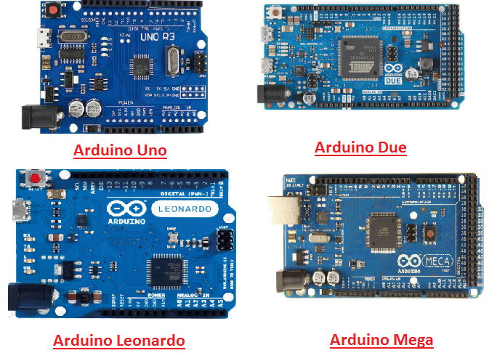
It is an open-source platform, means the boards and software are readily available and anyone can modify and optimize the boards for better functionality.
The software used for Arduino devices is called IDE (Integrated Development Environment) which is free to use and required some basic skills to learn it. It can be programmed using C and C++ language.
Some people get confused between Microcontroller and Arduino. While former is just an on system 40 pin chip that comes with a built-in microprocessor and later is a board that comes with the microcontroller in the base of the board, bootloader and allows easy access to input-output pins and makes uploading or burning of the program very easy.

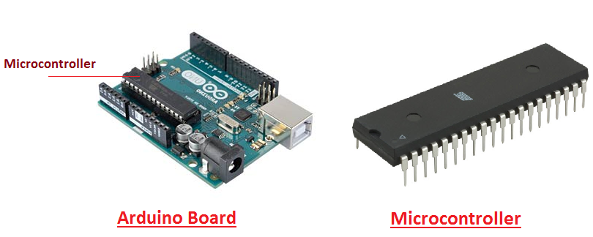

While learning microcontroller requires some expertise and skills.
Nevertheless, we can say every Arduino is basically a microcontroller but not every microcontroller is an Arduino.

Introduction to Arduino
- Arduino Uno is a microcontroller board developed by Arduino.cc which is an open-source electronics platform mainly based on AVR microcontroller Atmega328.
- First Arduino project was started in Interaction Design Institute Ivrea in 2003 by David Cuartielles and Massimo Banzi with the intention of providing a cheap and flexible way to students and professional for controlling a number of devices in the real world.
- The current version of Arduino Uno comes with USB interface, 6 analog input pins, 14 I/O digital ports that are used to connect with external electronic circuits. Out of 14 I/O ports, 6 pins can be used for PWM output.
- It allows the designers to control and sense the external electronic devices in the real world

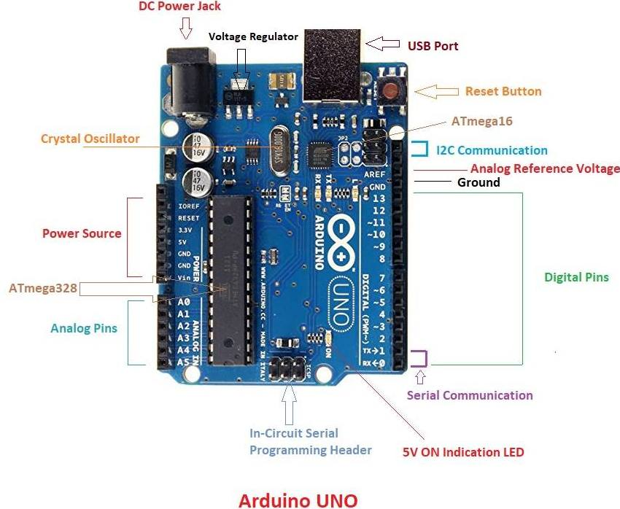
- This board comes with all the features required to run the controller and can be directly connected to the computer through USB cable that is used to transfer the code to the controller using IDE (Integrated Development Environment) software, mainly developed to program Arduino. IDE is equally compatible with Windows, MAC or Linux Systems, however, Windows is preferable to use. Programming languages like C and C++ are used in IDE.
- Apart from USB, battery or AC to DC adopter can also be used to power the board.
- Arduino Uno boards are quite similar to other boards in Arduino family in terms of use and functionality, however, Uno boards don’t come with FTDI USB to Serial driver chip.
- There are many versions of Uno boards available, however, Arduino Nano V3 and Arduino Uno are the most official versions that come with Atmega328 8-bit AVR Atmel microcontroller where RAM memory is 32KB.
- When nature and functionality of the task go complex, Mirco SD card can be added in the boards to make them store more information.
Features of Arduino
- Arduino Uno comes with USB interface i.e. USB port is added on the board to develop serial communication with the computer.
- Atmega328 microcontroller is placed on the board that comes with a number of features like timers, counters, interrupts, PWM, CPU, I/O pins and based on a 16MHz clock that helps in producing more frequency and number of instructions per cycle.

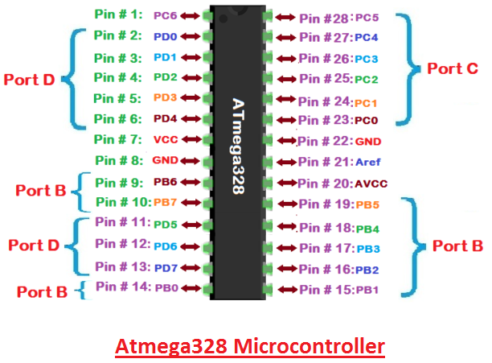
- It is an open source platform where anyone can modify and optimize the board based on the number of instructions and task they want to achieve.
- This board comes with a built-in regulation feature which keeps the voltage under control when the device is connected to the external device.
- Reset pin is added in the board that reset the whole board and takes the running program in the initial stage. This pin is useful when board hangs up in the middle of the running program; pushing this pin will clear everything up in the program and starts the program right from the beginning.
- There are 14 I/O digital and 6 analog pins incorporated in the board that allows the external connection with any circuit with the board. These pins provide the flexibility and ease of use to the external devices that can be connected through these pins. There is no hard and fast interface required to connect the devices to the board. Simply plug the external device into the pins of the board that are laid out on the board in the form of the header.
- The 6 analog pins are marked as A0 to A5 and come with a resolution of 10bits. These pins measure from 0 to 5V, however, they can be configured to the high range using analogReference() function and AREF pin.
- 13KB of flash memory is used to store the number of instructions in the form of code.
- Only 5 V is required to turn the board on, which can be achieved directly using USB port or external adopter, however, it can support external power source up to 12 V which can be regulated and limit to 5 V or 3.3 V based on the requirement of the project.
Arduino Pinout
- Arduino Uno is based on AVR microcontroller called Atmega328. This controller comes with 2KB SRAM, 32KB of flash memory, 1KB of EEPROM. Arduino Board comes with 14 digital pins and 6 analog pins. ON-chip ADC is used to sample these pins. A 16 MHz frequency crystal oscillator is equipped on the board. Following figure shows the pinout of the Arduino Uno Board
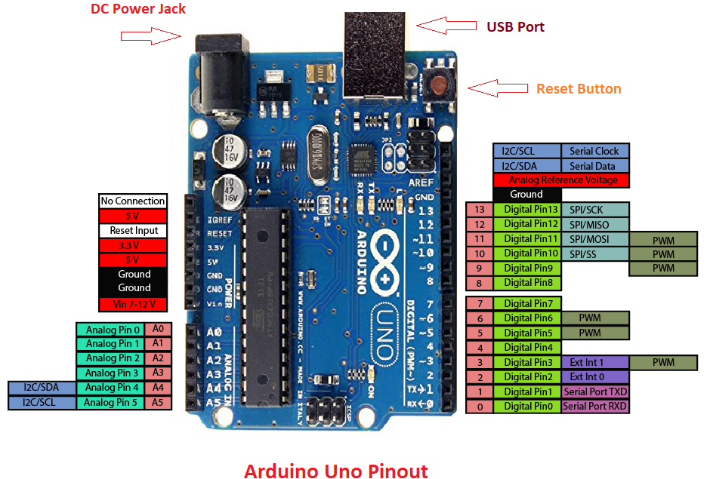
Pin Description:
There are several I/O digital and analog pins placed on the board which operates at 5V. These pins come with standard operating ratings ranging between 20mA to 40mA. Internal pull-up resistors are used in the board that limits the current exceeding from the given operating conditions. However, too much increase in current makes these resisters useless and damages the device.
LED. Arduino Uno comes with built-in LED which is connected through pin 13. Providing HIGH value to the pin will turn it ON and LOW will turn it OFF.
Vin. It is the input voltage provided to the Arduino Board. It is different than 5 V supplied through a USB port. This pin is used to supply voltage. If a voltage is provided through power jack, it can be accessed through this pin.
5V. This board comes with the ability to provide voltage regulation. 5V pin is used to provide output regulated voltage. The board is powered up using three ways i.e. USB, Vin pin of the board or DC power jack.
USB supports voltage around 5V while Vin and Power Jack support a voltage ranges between 7V to 20V. It is recommended to operate the board on 5V. It is important to note that, if a voltage is supplied through 5V or 3.3V pins, they result in bypassing the voltage regulation that can damage the board if voltage surpasses from its limit.
GND. These are ground pins. More than one ground pins are provided on the board which can be used as per requirement.
Reset. This pin is incorporated on the board which resets the program running on the board. Instead of physical reset on the board, IDE comes with a feature of resetting the board through programming.
IOREF. This pin is very useful for providing voltage reference to the board. A shield is used to read the voltage across this pin which then select the proper power source.
PWM. PWM is provided by 3, 5, 6,9,10, 11pins. These pins are configured to provide 8-bit output PWM.
SPI. It is known as Serial Peripheral Interface. Four pins 10(SS), 11(MOSI), 12(MISO), 13(SCK) provide SPI communication with the help of SPI library.
AREF. It is called Analog Reference. This pin is used for providing a reference voltage to the analog inputs.
TWI. It is called Two-wire Interface. TWI communication is accessed through Wire Library. A4 and A5 pins are used for this purpose.
Serial Communication. Serial communication is carried out through two pins called Pin 0 (Rx) and Pin 1 (Tx).
Rx pin is used to receive data while Tx pin is used to transmit data.
External Interrupts. Pin 2 and 3 are used for providing external interrupts. An interrupt is called by providing LOW or changing value.

Arduino Uno Technical Specifications
Microcontroller | ATmega328P – 8 bit AVR family microcontroller
Operating Voltage | 5V
Recommended Input Voltage | 7-12V
Input Voltage Limits | 6-20V
Analog Input Pins | 6 (A0 – A5)
Digital I/O Pins | 14 (Out of which 6 provide PWM output)
DC Current on I/O Pins | 40 mA
DC Current on 3.3V Pin | 50 mA
Flash Memory | 32 KB (0.5 KB is used for Bootloader)
SRAM | 2 KB
EEPROM | 1 KB
Frequency (Clock Speed) | 16 MHz

Communication and Programming:
Arduino Uno comes with an ability of interfacing with other other Arduino boards, microcontrollers and computer. The Atmega328 placed on the board provides serial communication using pins like Rx and Tx.
The Atmega16U2 incorporated on the board provides a pathway for serial communication using USB com drivers. Serial monitor is provided on the IDE software which is used to send or receive text data from the board. If LEDs placed on the Rx and Tx pins will flash, they indicate the transmission of data.
Arduino Uno is programmed using Arduino Software which a cross-platform application called IDE is written in Java. The AVR microcontroller Atmega328 laid out on the base comes with built-in boot loader that sets you free from using a separate burner to upload the program on the board.

Applications:
Arduino Uno comes with a wide range of applications. A larger number of people are using Arduino boards for developing sensors and instruments that are used in scientific research. Following are some main applications of the board.
- Embedded System
- Security and Defense System
- Digital Electronics and Robotics
- Parking Lot Counter
- Weighing Machines
- Traffic Light Count Down Timer
- Medical Instrument
- Emergency Light for Railways
- Home Automation
- Industrial Automation
There are a lot of other microcontrollers available in the market that are more powerful and cheap as compared to Arduino board. So, why you prefer Arduino Uno?
Actually, Arduino comes with a big community that is developing and sharing the knowledge with a wide range of audience. Quick support is available pertaining to technical aspects of any electronic project. When you decide Arduino board over other controllers, you don’t need to arrange extra peripherals and devices as most of the functions are readily available on the board that makes your project economical in nature and free from a lot of technical expertise.

Raspberry Pi:
INTRODUCTION OF RASPBERRY PI:
Raspberry Pi is a credit-card sized computer manufactured and designed in the United Kingdom by the Raspberry Pi foundation with the intention of teaching basic computer science to school students and every other person interested in computer hardware, programming and DIY-Do-it Yourself projects.
The Raspberry Pi is manufactured in three board configurations through licensed manufacturing deals with Newark element 14(Premier Farnell), RS Components and Egoman. These companies sell the Raspberry Pi online. Egoman produces a version for distribution solely in China and Taiwan, which can be distinguished from other Pi’s by their red coloring and lack of FCC/CE marks. The hardware is the same across all manufacturers.
The Raspberry Pi has a Broadcom BCM2835 system on a chip (SoC), which includes an ARM1176JZF-S 700 MHz processor, Video Core IV GPU and was originally shipped with 256 megabytes of RAM, later upgraded (Model B & Model B+) to 512 MB. It does not include a built-in hard disk or solid-state drive, but it uses an SD card for booting and persistent storage, with the Model B+ using a MicroSD.
The Foundation provides Debian and Arch Linux ARM distributions for download. Tools are available for Python as the main programming language, with support for BBC BASIC (via the RISC OS image or the Brandy Basic clone for Linux), C, Java and Perl.
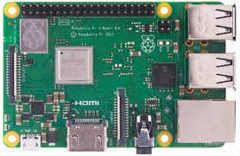
HARDWARE LAYOUT:

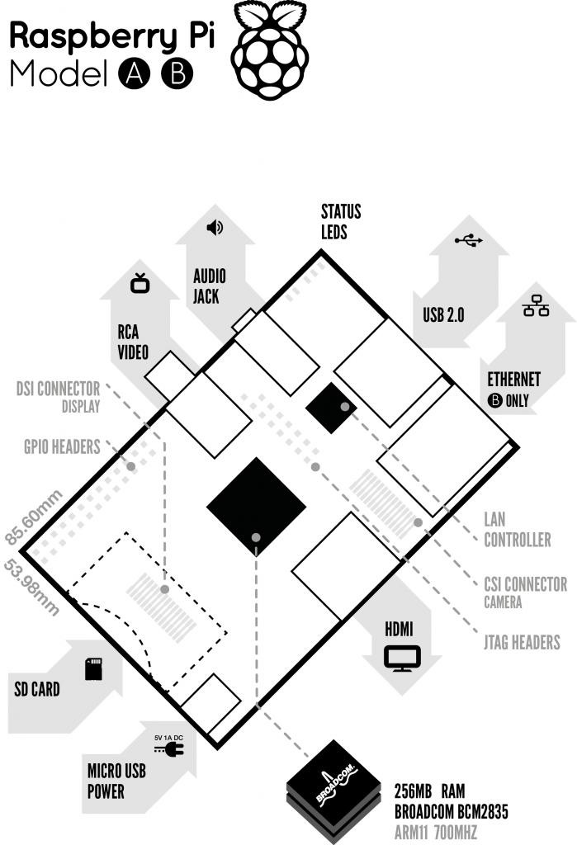

Figure 5: Block Diagram of Raspberry Pi
DESCRIPTION OF THE COMPONENTS ON THE RASPBERRY PI:
1) Processor/SoC(System on Chip):
The Raspberry Pi has a Broadcom BCM2835 System on Chip module. It has a ARM1176JZF-S processor. The Broadcom SoC used in the Raspberry Pi is equivalent to a chip used in an old smartphone. While operating at 700 MHz by default, the Raspberry Pi provides a real world performance roughly equivalent to the 0.041GFLOPS. The Raspberry Pi chip operating at 700 MHz by default, will not become hot enough to need a heatsink or special cooling.

2) Power source:
The Pi is a device which consumes 700mA or 3W or power. It is powered by a Micro USB charger or the GPIO header. Any good smartphone charger will do the work of powering the Pi.

3) SD Card:
The Raspberry Pi does not have any onboard storage available. The operating system is loaded on a SD card which is inserted on the SD card slot on the Raspberry Pi. The operating system can be loaded on the card using a card reader on any computer.

4) GPIO:
General-purpose input/output (GPIO) is a generic pin on an integrated circuit whose behavior, including whether it is an input or output pin, can be controlled by the user at run time. GPIO pins have no special purpose defined, and go unused by default. The idea is that sometimes the system designer building a full system that uses the chip might find it useful to have a handful of additional digital control lines, and having these available from the chip can save the hassle of having to arrange additional circuitry.
The production Raspberry Pi board has a 26-pin 2.54 mm expansion header, marked as P1, arranged in a 2x13 strip. They provide 8 GPIO pins plus access to I²C, SPI, UART), as well as +3.3 V, +5 V and GND supply lines. Pin one is the pin in the first column and on the bottom row.
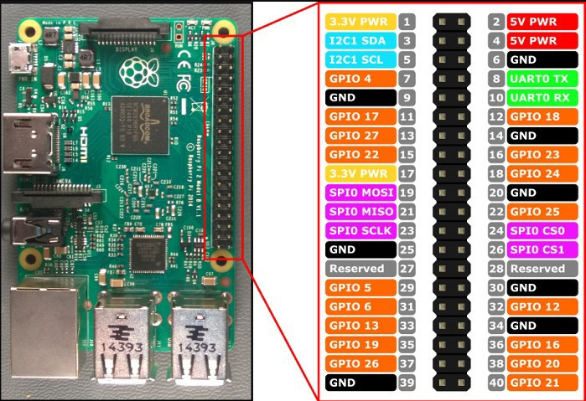

5) DSI connector:
The Display Serial Interface (DSI) is a specification by the Mobile Industry Processor Interface (MIPI) Alliance aimed at reducing the cost of display controllers in a mobile device. It is commonly targeted at LCD and similar display technologies. It defines a serial bus and a communication protocol between the host and the device. A DSI compatible LCD screen can be connected through the DSI connector, although it may require additional drivers to drive the display.

6) RCA Video:
RCA Video outputs (PAL and NTSC) are available on all models of Raspberry Pi. Any television or screen with a RCA jack can be connected with the RPi.
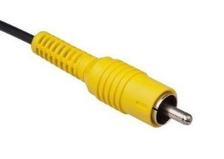

Figure 6: RCA Video Connector
7) Audio Jack:
A standard 3.5 mm TRS connector is available on the RPi for stereo audio output. Any headphone or 3.5mm audio cable can be connected directly. Although this jack cannot be used for taking audio input, USB mics or USB sound cards can be used.

8) Status LEDs:
There are 5 status LEDs on the RPi that show the status of various activities. They are “OK” ,"ACT" ,,“POWER” (PWR),Full Duplex ("FDX"),“LNK” ( Link/Activity), “10M/100” which are shown in figure below.
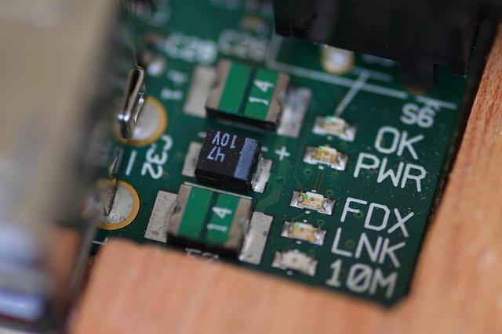

Figure 7: Status LEDs
9) USB 2.0 Port:
USB 2.0 ports are the means to connect accessories such as mouse or keyboard to the Raspberry Pi. There is 1 port on Model A, 2 on Model B and 4 on Mo del B+. The number of ports can be increased by using an external powered USB hub which is available as a standard Pi accessory.

10) Ethernet:
Ethernet port is available on Model B and B+. It can be connected to a network or internet using a standard LAN cable on the Ethernet port. The Ethernet ports are controlled by Microchip LAN9512 LAN controller chip.

11) CSI connector:
CSI – Camera Serial Interface is a serial interface designed by MIPI (Mobile Industry Processor Interface) alliance aimed at interfacing digital cameras with a mobile processor. The RPi foundation provides a camera specially made for the Pi which can be connected with the Pi using the CSI connector.

12) JTAG headers:
JTAG is an acronym for ‘Joint Test Action Group', an organization that started back in the mid 1980's to address test point access issues on PCB with surface mount devices. The organization devised a method of access to device pins via a serial port that became known as the TAP (Test Access Port). In 1990 the method became a recognized international standard (IEEE Std 1149.1). Many thousands of devices now include this standardized port as a feature to allow test and design engineers to access pins.

13) HDMI:
HDMI –High Definition Multimedia Interface
HDMI 1.3 a type A port is provided on the RPi to connect with HDMI screens.
SPECIFICATIONS:

 | Model A | Model B | Model B+
Target price: | US$25 | US$35
SoC: | Broadcom BCM2835 (CPU, GPU, DSP, SDRAM, and single USB port)
CPU: | 700 MHz ARM1176JZF-S core (ARM11 family, ARMv6 instruction set)
GPU: | Broadcom Video Core IV @ 250 MHz
Memory  (SDRAM): | 256 MB  GPU) | 512 MB (shared with GPU)
USB 2.0 ports: | 1 (direct from BCM2835 chip)  BCM2835 chip) | 2 (via the on-board 3- port USB hub) | 4 (via the on-board 5- port USB hub)
Video input: | 15-pin MIPI camera interface (CSI) connector, used with the Raspberry Pi  Camera Addon.
Video outputs: | Composite RCA (PAL and NTSC) –in model B+ via 4-pole 3.5 mm jack, HDMI (rev 1.3 & 1.4), raw LCD Panels via DS
Audio outputs: | 3.5 mm jack, HDMI, and, as of revision 2 boards, I²S audio (also potentially  for audio input)
Onboard storage: | SD / MMC / SDIO card slot (3.3 V card power support only)  support only) |  | MicroSD
Onboard network: | None | 10/100 Mbit/s Ethernet (8P8C) USB adapter on the third/fifth port of the USB hub
Low-level peripherals: | 8× GPIO, UART, I²C bus, SPI bus with two chip selects, I²S audio +3.3 V, +5 V, ground |  | 17× GPIO

Power ratings: | 300 mA (1.5 W) | 700 mA (3.5 W) | 600 mA (3.0 W)
Power source: | 5 V via Micro USB or GPIO header
Size: | 85.60 mm × 56 mm (3.370 in × 2.205 in) – not including protruding  Connectors
Weight: | 45 g (1.6 oz)
Table 1 Specifications
BRIEF DESCRIPTION OF SYSTEM ON CHIP (SoC):
Since smartphones and tablets are basically smaller computers, they require pretty much the same components we see in desktops and laptops in order to offer us all the amazing things they can do (apps, music and video playing, 3D gaming support, advanced wireless features, etc). But smartphones and tablets do not offer the same amount of internal space as desktops and laptops for the various components needed such as the logic board, the processor, the RAM, the graphics card, and others. That means these internal parts need to be as small as possible, so that device manufacturers can use the remaining space to fit the device with a long-lasting battery life. A system on a chip or system on chip is an integrated circuit (IC) that integrates all components of a computer or other electronic system into a single chip. It may contain digital, analog, mixed-signal, and often radio-frequency functions—all on a single chip substrate. SoCs are very common in the mobile electronics market because of their low power consumption. A typical application is in the area of embedded systems.
The contrast with a microcontroller is one of degree. Microcontrollers typically have under 100 kB of RAM (often just a few kilobytes) and often really are single-chip- systems, whereas the term SoC is typically used for more powerful processors, capable of running software such as the desktop versions of Windows and Linux, which need external memory chips (flash, RAM) to be useful, and which are used with various external peripherals. In short, for larger systems, the term system on a chip is a hyperbole, indicating technical direction more than reality: increasing chip integration to reduce manufacturing costs and to enable smaller systems. Many interesting systems are too complex to fit on just one chip built with a process optimized for just one of the system's tasks.
ACCESSORIES:
Raspberry Pi being a very cheap computer has attracted millions of users around the world. Thus it has a large user base. Many enthusiasts have created accessories and peripherals for the Raspberry Pi. This range from USB hubs, motor controllers to temperature sensors. There are some official accessories for the RPi as follows:
Camera – The Raspberry Pi camera board contains a 5 MPixel sensor, and connects via a ribbon cable to the CSI connector on the Raspberry Pi. In Raspbian support can be enabled by the installing or upgrading to the latest version of the OS and then running Raspi-config and selecting the camera option.
Gertboard – A Raspberry Pi Foundation sanctioned device designed for educational purposes, and expands the Raspberry Pi's GPIO pins to allow interface with and control of LEDs, switches, analog signals, sensors and other devices. It also includes an optional Arduino compatible controller to interface with the Pi. The Gertboard can be used to control motors, switches etc. for robotic projects.
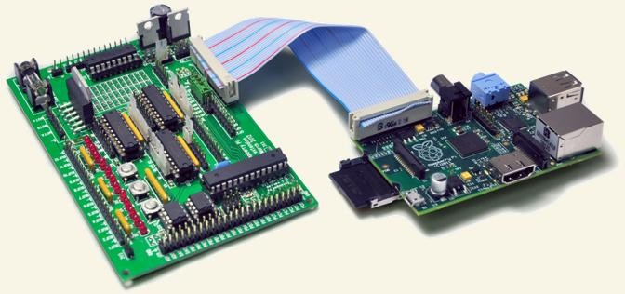

Figure 8:Gertboard(left) & Raspberry Pi(Right)

USB Hub – Although not an official accessory, it is a highly recommended accessory for the Pi. A powered USB Hub with 7 extra ports is available at almost all online stores. It is compulsory to use a USB Hub to connect external hard disks or other accessories that draw power from the USB ports, as the Pi cannot give power to them.
WEB CAMERA
A webcam is a video camera that feeds or streams an image or video in real time to or through a computer network, such as the Internet. Webcams are typically small cameras that sit on a desk, attach to a user's monitor, or are built into the hardware. Webcams can be used during a video chat session involving two or more people, with conversations that include live audio and video.
Webcam software enables users to record a video or stream the video on the Internet. As video streaming over the Internet requires much bandwidth, such streams usually use compressed formats. The maximum resolution of a webcam is also lower than most handheld video cameras, as higher resolutions would be reduced during transmission. The lower resolution enables webcams to be relatively inexpensive compared to most video cameras, but the effect is adequate for video chat sessions
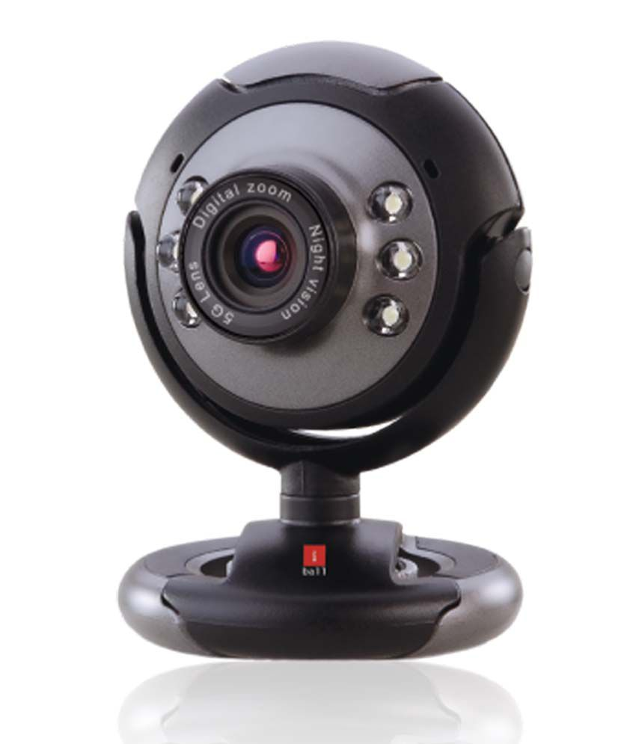

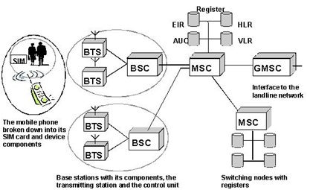

Solar panel:
Photovoltaic solar panels absorb sunlight as a source of energy to generate electricity. A photovoltaic (PV) module is a packaged, connected assembly of typically 6x10 photovoltaic solar cells. Photovoltaic modules constitute the photovoltaic array of a photovoltaic system that generates and supplies solar electricity in commercial and residential applications.
The most common application of solar energy collection outside agriculture is solar water heating systems.

Theory and construction
Photovoltaic modules use light energy (photons) from the Sun to generate electricity through the photovoltaic effect. The majority of modules use wafer-based crystalline silicon cells or thin-film cells. The structural (load carrying) member of a module can either be the top layer or the back layer. Cells must also be protected from mechanical damage and moisture. Most modules are rigid, but semi-flexible ones based on thin-film cells are also available. The cells must be connected electrically in series, one to another.
A PV junction box is attached to the back of the solar panel and it is its output interface. Externally, most of photovoltaic modules use MC4 connectors type to facilitate easy weatherproof connections to the rest of the system. Also, USB power interface can be used.
Module electrical connections are made in series to achieve a desired output voltage or in parallel to provide a desired current capability (amperes). The conducting wires that take the current off the modules may contain silver, copper or other non-magnetic conductive transition metals. Bypass diodes may be incorporated or used externally, in case of partial module shading, to maximize the output of module sections still illuminated.
Some special solar PV modules include concentrators in which light is focused by lenses or mirrors onto smaller cells. This enables the use of cells with a high cost per unit area (such as gallium arsenide) in a cost-effective way.
Solar panels also use metal frames consisting of racking components, brackets, reflector shapes, and troughs to better support the panel structure.
Technology:
Most solar modules are currently produced from crystalline silicon (c-Si) solar cells made of multicrystalline and monocrystalline silicon. In 2013, crystalline silicon accounted for more than 90 percent of worldwide PV production, while the rest of the overall market is made up of thin-film technologies using cadmium telluride, CIGS and amorphous silicon^{[16]}
Emerging, third generation solar technologies use advanced thin-film cells. They produce a relatively high-efficiency conversion for the low cost compared to other solar technologies. Also, high-cost, high-efficiency, and close-packed rectangular multi-junction (MJ) cells are preferably used in solar panels on spacecraft, as they offer the highest ratio of generated power per kilogram lifted into space. MJ-cells are compound semiconductors and made of gallium arsenide (GaAs) and other semiconductor materials. Another emerging PV technology using MJ-cells is concentrator photovoltaics ( CPV ).

Thin film
In rigid thin-film modules, the cell and the module are manufactured in the same production line. The cell is created on a glass substrate or superstrate, and the electrical connections are created in situ, a so-called "monolithic integration". The substrate or superstrate is laminated with an encapsulant to a front or back sheet, usually another sheet of glass. The main cell technologies in this category are CdTe, or a-Si, or a-Si+uc-Si tandem, or CIGS (or variant). Amorphous silicon has a sunlight conversion rate of 6–12%
Flexible thin film cells and modules are created on the same production line by depositing the photoactive layer and other necessary layers on a flexible substrate. If the substrate is an insulator (e.g. polyester or polyimide film) then monolithic integration can be used. If it is a conductor then another technique for electrical connection must be used. The cells are assembled into modules by laminating them to a transparent colourless fluoropolymer on the front side (typically ETFE or FEP) and a polymer suitable for bonding to the final substrate on the other side.
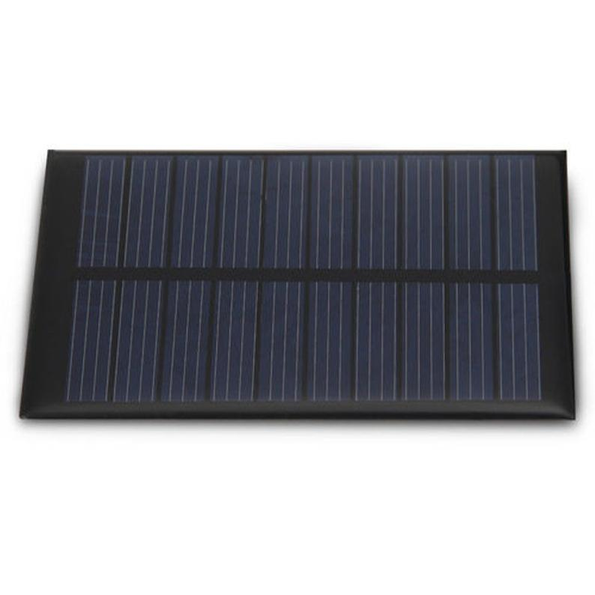

Light Emitting Diodes (LEDs)

The Light emitting diode is a two-lead semiconductor light source. In 1962, Nick Holonyak has come up with an idea of light emitting diode, and he was working for the general electric company. The LED is a special type of diode and they have similar electrical characteristics of a PN junction diode. Hence the LED allows the flow of current in the forward direction and blocks the current in the reverse direction. The LED occupies the small area which is less than the 1 mm². The applications of LEDs used to make various electrical and electronic projects. In this article, we will discuss the working principle of the LED and its applications.

What is a Light Emitting Diode?
The lighting emitting diode is a p-n junction diode. It is a specially doped diode and made up of a special type of semiconductors. When the light emits in the forward biased, then it is called as a light emitting diode.

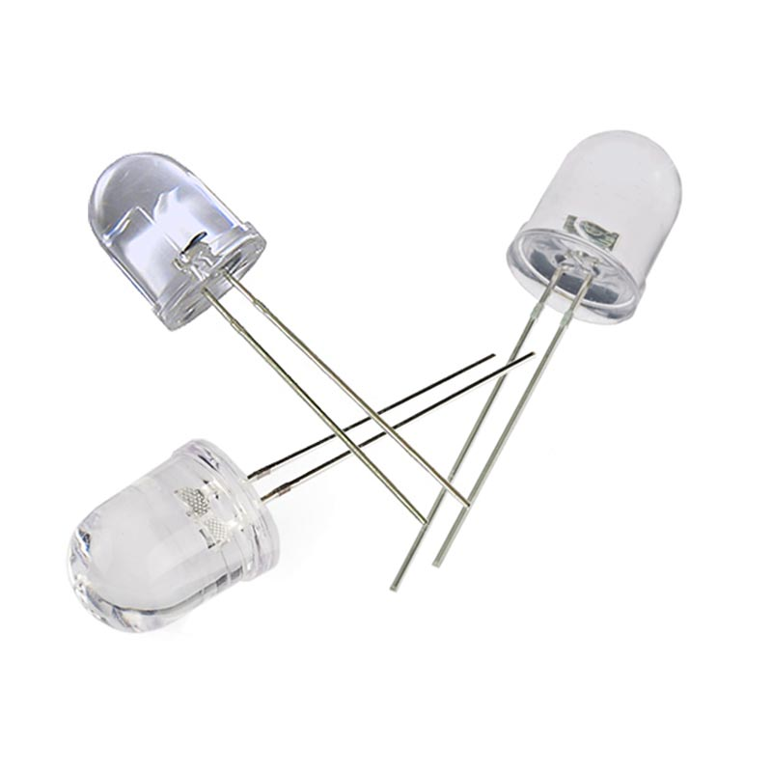

How does the Light Emitting Diode work?
The light emitting diode simply, we know as a diode. When the diode is forward biased, then the electrons & holes are moving fast across the junction and they are combining constantly, removing one another out. Soon after the electrons are moving from the n-type to the p-type silicon, it combines with the holes, then it disappears. Hence it makes the complete atom & more stable and it gives the little burst of energy in the form of a tiny packet or photon of light.

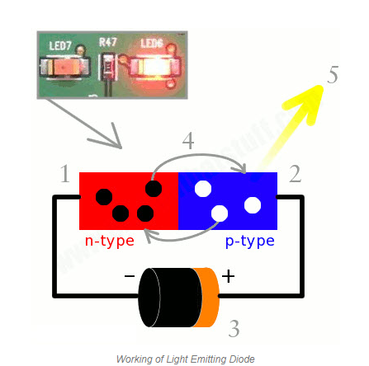

Schematic:

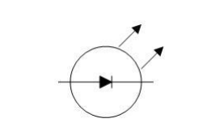

- A Light emitting diode (LED) is essentially a pn junction diode. When carriers are injected across a forward-biased junction, it emits incoherent light.

- Most of the commercial LEDs are realized using a highly doped n and a p Junction.

LED Materials:
A critical class of business LEDs that cover the unmistakable range. Ternary composites in view of alloying GaAs and GaP which are signified by GaAs1-yPy. InGaAlP is a case of a quarternary (four component) III-V compound with an immediate band crevice. The LEDs acknowledged utilizing two diversely doped semiconductors that are the same material is known as a homojunction. When they are acknowledged utilizing diverse bandgap materials they are known as a heterostructure gadget heterostructure LED is brighter than a homoJunction LED.
LED Structure:
The LED structure assumes a vital part in radiating light from the LED surface. The LEDs are organized to guarantee the majority of the recombinations happens at first glance by the accompanying two ways. • By expanding the doping grouping of the substrate, so that extra free minority charge transporters electrons move to the top, recombine and emanate light at the surface. • By expanding the dissemination length L = √ Dτ, where D is the dispersion coefficient and τ is the bearer life time. In any case, when expanded past a basic length there is a possibility of re-retention of the photons into the gadget. The LED must be organized so that the photons produced from the gadget are transmitted without being reabsorbed. One arrangement is to make the p layer on the top, sufficiently flimsy to make an exhaustion layer. Taking after picture demonstrates the layered structure. There are diverse approaches to structure the vault for proficient transmitting.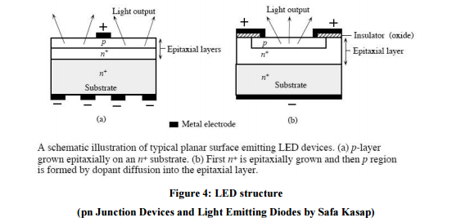
LEDs are normally based on a n-sort substrate, with a terminal joined to the p-sort layer saved on its surface. P-sort substrates, while less basic, happen too. Numerous business LEDs, particularly GaN/InGaN, likewise utilize sapphire substrate. Driven productivity: A vital metric of a LED is the outside quantum proficiency next. It measures the efficiency of the transformation of electrical vitality into transmitted optical vitality. It is characterized as the light yield isolated by the electrical information power.

It is likewise characterized as the result of Internal radiative proficiency and Extraction productivity. ηext = Pout(optical)/IV For backhanded band gap semiconductors ηext is for the most part under 1%, where concerning an immediate band hole material it could be generous. ηint = rate of radiation recombination/Total recombination The interior effectiveness is an element of the nature of the material and the structure and arrangement of the layer.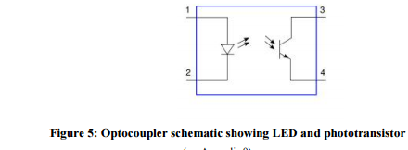
Applications:
LED have a lot of applications. Following are few examples.
• Devices, medical applications, clothing, toys
• Remote Controls (TVs, VCRs)
• Lighting
• Indicators and signs
• Optoisolators and optocouplers
• Swimming pool lighting
Advantages of using LEDs
• LEDs deliver more light per watt than radiant knobs; this is valuable in battery fueled or vitality sparing gadgets.
• LEDs can radiate light of a planned shading without the utilization of shading channels that customary lighting techniques require. This is more effective and can bring down introductory expenses.
• The strong bundle of the LED can be intended to center its light. Glowing and fluorescent sources frequently require an outside reflector to gather light and direct it in a usable way.
• When utilized as a part of utilizations where darkening is required, LEDs don't change their shading tint as the present going through them is brought down, not at all like radiant lights, which turn yellow.
• LEDs are perfect for use in applications that are liable to visit on-off cycling, not at all like fluorescent lights that copy out all the more immediately when cycled much of the time, or High Intensity Discharge (HID) lights that require quite a while before restarting.
• LEDs, being strong state segments, are hard to harm with outer stun. Fluorescent and radiant globules are effectively broken if dropped on the ground.
• LEDs can have a moderately long valuable life. A Philips LUXEON k2 LED has an existence time of around 50,000 hours, though Fluorescent tubes commonly are appraised at around 30,000 hours, and brilliant lights at 1,000–2,000 hours.
• LEDs generally fall flat by darkening after some time, as opposed to the unexpected wear out of brilliant globules.
• LEDs illuminate rapidly. A run of the mill red marker LED will accomplish full brilliance in microseconds; Philips Lumileds specialized datasheet DS23 for the Luxeon Star states "under 100ns." LEDs utilized as a part of specialized gadgets can have significantly quicker reaction times.
• LEDs can be little and are effortlessly populated onto printed circuit sheets.
• LEDs don't contain mercury, not at all like conservative fluorescent lights.

Motor Driver:
A motor driver is an integrated circuit chip which is usually used to control motors in autonomous robots. Motor driver act as an interface between Arduino and the motors. The most commonly used motor driver IC’s are from the L293 series such as L293D, L293NE, etc. These ICs are designed to control 2 DC motors simultaneously. L293D consist of two H-bridge. H-bridge is the simplest circuit for controlling a low current rated motor. We will be referring the motor driver IC as L293D only. L293D has 16 pins.
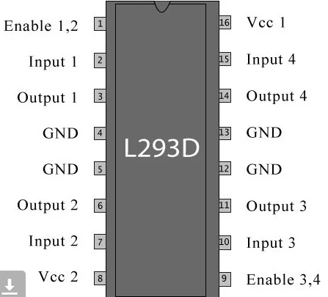
The L293D is a 16 pin IC, with eight pins, on each side, dedicated to the controlling of a motor. There are 2 INPUT pins, 2 OUTPUT pins and 1 ENABLE pin for each motor. L293D consist of two H-bridge. H-bridge is the simplest circuit for controlling a low current rated motor.
Pin Number | Pin Name | Description
1 | Enable 1,2 | This pin enables the input pin Input 1(2) and Input 2(7)
2 | Input 1 | Directly controls the Output 1 pin. Controlled by digital circuits
3 | Output 1 | Connected to one end of Motor 1
4 | Ground | Ground pins are connected to ground of circuit (0V)
5 | Ground | Ground pins are connected to ground of circuit (0V)
6 | Output 2 | Connected to another end of Motor 1
7 | Input 2 | Directly controls the Output 2 pin. Controlled by digital circuits
8 | Vcc2 (Vs) | Connected to Voltage pin for running motors (4.5V to 36V)
9 | Enable 3,4 | This pin enables the input pin Input 3(10) and Input 4(15)
10 | Input 3 | Directly controls the Output 3 pin. Controlled by digital circuits
11 | Output 3 | Connected to one end of Motor 2
12 | Ground | Ground pins are connected to ground of circuit (0V)
13 | Ground | Ground pins are connected to ground of circuit (0V)
14 | Output 4 | Connected to another end of Motor 2
15 | Input 4 | Directly controls the Output 4 pin. Controlled by digital circuits
16 | Vcc2 (Vss) | Connected to +5V to enable IC function
Working of L293D
There are 4 input pins for l293d, pin 2, 7 on the left and pin 15, 10 on the right as shown on the pin diagram. Left input pins will regulate the rotation of motor connected across left side and right input for motor on the right hand side. The motors are rotated on the basis of the inputs provided across the input pins as LOGIC 0 or LOGIC 1.
In simple you need to provide Logic 0 or 1 across the input pins for rotating the motor.
L293D Logic Table.
Let’s consider a Motor connected on left side output pins (pin 3, 6). For rotating the motor in clockwise direction the input pins has to be provided with Logic 1 and Logic 0.
Pin 2 = Logic 1 and Pin 7 = Logic 0 | Clockwise Direction
Pin 2 = Logic 0 and Pin 7 = Logic 1 | Anticlockwise Direction
Pin 2 = Logic 0 and Pin 7 = Logic 0 | Idle [No rotation] [Hi-Impedance state]
Pin 2 = Logic 1 and Pin 7 = Logic 1 | Idle [No rotation]
Circuit Diagram for l293d motor driver IC controller
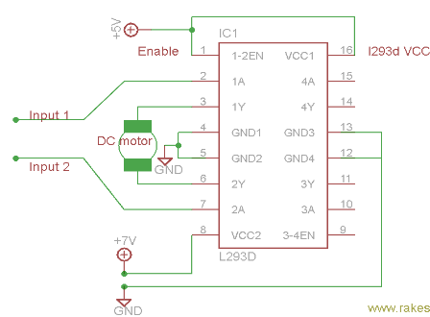

Voltage Specification
VCC is the voltage that it needs for its own internal operation 5v; L293D will not use this voltage for driving the motor. For driving the motors it has a separate provision to provide motor supply VSS (V supply). L293d will use this to drive the motor. It means if you want to operate a motor at 9V then you need to provide a Supply of 9V across VSS Motor supply.
The maximum voltage for VSS motor supply is 36V. It can supply a max current of 600mA per channel. Since it can drive motors Up to 36v hence you can drive pretty big motors with this l293d. VCC pin 16 is the voltage for its own internal Operation. The maximum voltage ranges from 5v and up to 36v.

What is a DC Motor?

A direct current (DC) motor is a type of electric machine that converts electrical energy into mechanical energy. DC motors take electrical power through direct current, and convert this energy into mechanical rotation.

DC motors use magnetic fields that occur from the electrical currents generated, which powers the movement of a rotor fixed within the output shaft. The output torque and speed depends upon both the electrical input and the design of the motor.

How DC motors work

The term ‘DC motor’ is used to refer to any rotary electrical machine that converts direct current electrical energy into mechanical energy. DC motors can vary in size and power from small motors in toys and appliances to large mechanisms that power vehicles, pull elevators and hoists, and drive steel rolling mills.

But how do DC motors work?

DC motors include two key components: a stator and an armature. The stator is the stationary part of a motor, while the armature rotates. In a DC motor, the stator provides a rotating magnetic field that drives the armature to rotate.

A simple DC motor uses a stationary set of magnets in the stator, and a coil of wire with a current running through it to generate an electromagnetic field aligned with the centre of the coil. One or more windings of insulated wire are wrapped around the core of the motor to concentrate the magnetic field.

The windings of insulated wire are connected to a commutator (a rotary electrical switch), that applies an electrical current to the windings. The commutator allows each armature coil to be energised in turn, creating a steady rotating force (known as torque).

When the coils are turned on and off in sequence, a rotating magnetic field is created that interacts with the differing fields of the stationary magnets in the stator to create torque, which causes it to rotate. These key operating principles of DC motors allow them to convert the electrical energy from direct current into mechanical energy through the rotating movement, which can then be used for the propulsion of objects.

Who invented the DC motor?

This amazing piece of electrical equipment has revolutionised our lives in many ways, but who invented the DC motor? As with all major innovations, there are many people who had a role to play through the development of similar mechanisms.

In the US, Thomas Davenport is widely celebrated as the inventor of the first electric motor, and undoubtedly he was the first to patent a useable electric motor in 1837. Davenport, however, was not the first person to build an electric motor, with various inventors in Europe having already developed more powerful versions by the time Davenport filed his patent.

In 1834, Moritz Jacobi had presented a motor that was three times as powerful as the one Davenport would later patent, while Sibrandus Stratingh and Christopher Becker were the first to demonstrate a practical application for an electric motor, by running a small model car in 1835.
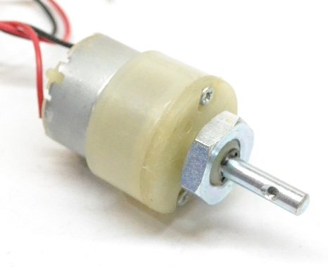
The first practical DC motor was invented some years later in 1886 by Frank Julian Sprague, whose invention lead to the first motor powered trolley system in 1887, and the first electric elevator in 1892. Sprague’s DC motor was a hugely significant development, leading to a variety of applications which would reshape the face of industry and manufacturing.

Types of DC Motors

So far, this guide has broadly explained how DC motors work, the history of these mechanisms, and what they look like. While the principles are the same across variants, there are actually several different types of DC motors, which offer specific advantages and disadvantages over each other.
DC Water Pump:
DC powered pumps use direct current from motor, battery, or solar power to move fluid in a variety of ways. Motorized pumps typically operate on 6, 12, 24, or 32 volts of DC power. Solar-powered DC pumps use photovoltaic (PV) panels with solar cells that produce direct current when exposed to sunlight.
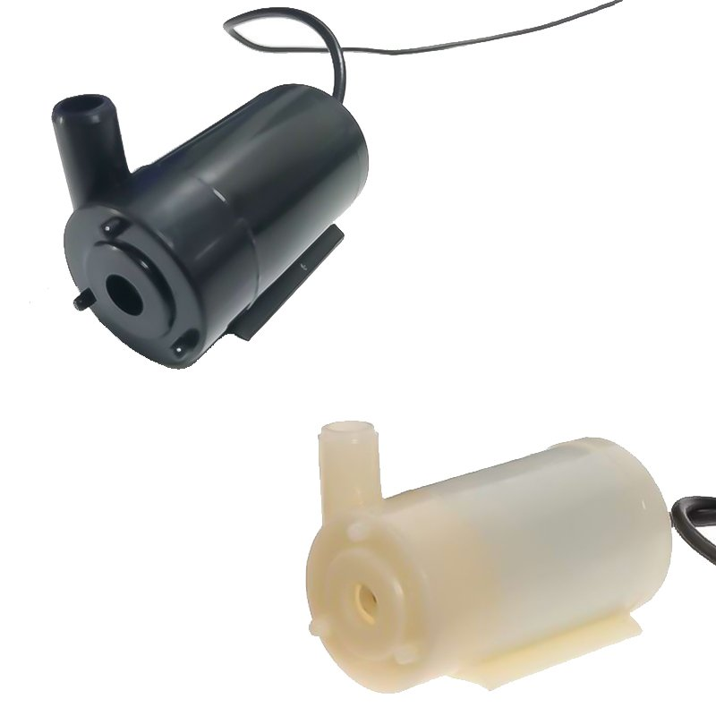
DC Pump Classification:
1. Brush DC water pump
2. Brushless DC magnetic drive isolated water pump
3. Brushless motor DC water pump

Working principle:
1. Working principle of brushed DC water pump：
Disadvantages: As long as the motor rotates the carbon brushes, they will wear out. When the water pump runs to a certain level, the carbon brush wear gap will increase and the sound will increase. After hundreds of hours of continuous operation, the carbon brushes will not be able to change direction. Up.
Advantages: low price.

2. The working principle of brushless motor DC water pump：
The motor-type brushless DC pump is composed of a brushless DC motor and an impeller. The shaft of the motor is connected to the impeller.
Disadvantages: There is a gap between the stator and the rotor of the water pump. After a long time of use, the water will penetrate into the motor and the motor will easily burn out.
Advantages: The brushless DC motor has been standardized and mass-produced by specialized manufacturers, with relatively low cost and high efficiency.

Relay:
What is a relay?
A relay is an electromagnetic switch that is used to turn on and turn off a circuit by a low power signal, or where several circuits must be controlled by one signal.
Most of the high end industrial application devices have relays for their effective working. Relays are simple switches which are operated both electrically and mechanically. Relays consist of an electromagnet and also a set of contacts. The switching mechanism is carried out with the help of the electromagnet. There are also other operating principles for its working. But they differ according to their applications. Most of the devices have the application of relays.
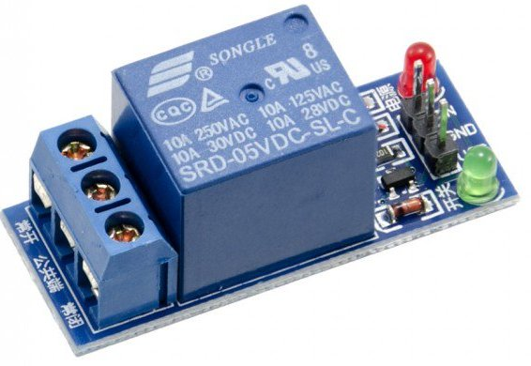

Pin Diagram:

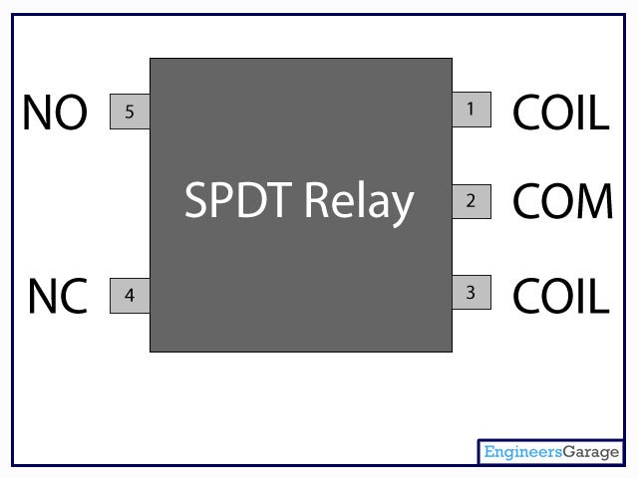
Why is a relay used?
The main operation of a relay comes in places where only a low-power signal can be used to control a circuit. It is also used in places where only one signal can be used to control a lot of circuits. The application of relays started during the invention of telephones. They played an important role in switching calls in telephone exchanges. They were also used in long distance telegraphy. They were used to switch the signal coming from one source to another destination. After the invention of computers they were also used to perform Boolean and other logical operations. The high end applications of relays require high power to be driven by electric motors and so on. Such relays are called contactors.

Relay Design
- There are only four main parts in a relay. They are
- Electromagnet
- Movable Armature
- Switch point contacts
- Spring
The figures given below show the actual design of a simple relay.
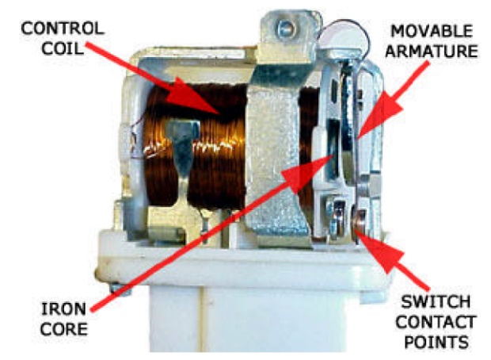
Relay Construction
It is an electro-magnetic relay with a wire coil, surrounded by an iron core. A path of very low reluctance for the magnetic flux is provided for the movable armature and also the switch point contacts.
The movable armature is connected to the yoke which is mechanically connected to the switch point contacts. These parts are safely held with the help of a spring. The spring is used so as to produce an air gap in the circuit when the relay becomes de-energized.

How relay works?
The relay function can be better understood by explaining the following diagram given below.
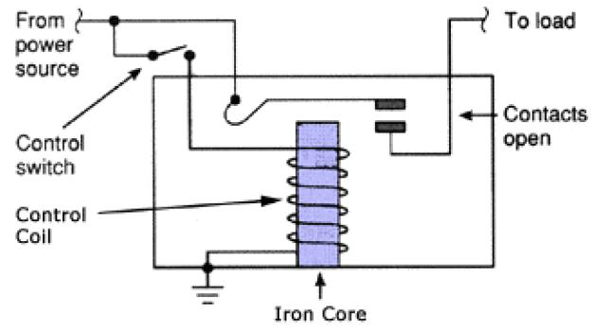
Relay Design
The diagram shows an inner section diagram of a relay. An iron core is surrounded by a control coil. As shown, the power source is given to the electromagnet through a control switch and through contacts to the load. When current starts flowing through the control coil, the electromagnet starts energizing and thus intensifies the magnetic field. Thus the upper contact arm starts to be attracted to the lower fixed arm and thus closes the contacts causing a short circuit for the power to the load. On the other hand, if the relay was already de-energized when the contacts were closed, then the contact move oppositely and make an open circuit.
As soon as the coil current is off, the movable armature will be returned by a force back to its initial position. This force will be almost equal to half the strength of the magnetic force. This force is mainly provided by two factors. They are the spring and also gravity.
Relays are mainly made for two basic operations. One is low voltage application and the other is high voltage. For low voltage applications, more preference will be given to reduce the noise of the whole circuit. For high voltage applications, they are mainly designed to reduce a phenomenon called arcing.

Relay Basics
The basics for all the relays are the same. Take a look at a 4 pin relay shown below. There are two colors shown. The green color represents the control circuit and the red color represents the load circuit. A small control coil is connected onto the control circuit. A switch is connected to the load. This switch is controlled by the coil in the control circuit. Now let us take the different steps that occur in a relay.
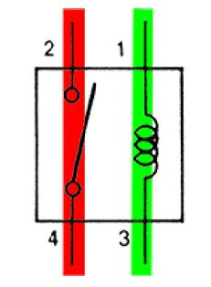
Relay operation
- Energized Relay (ON)
As shown in the circuit, the current flowing through the coils represented by pins 1 and 3 causes a magnetic field to be aroused. This magnetic field causes the closing of the pins 2 and 4. Thus the switch plays an important role in the relay working. As it is a part of the load circuit, it is used to control an electrical circuit that is connected to it. Thus, when the electrical relay in energized the current flow will be through the pins 2 and 4.
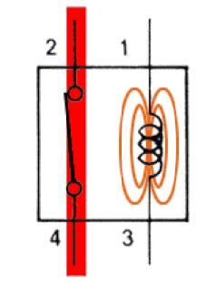
Energized Relay (ON)
- De – Energized Relay (OFF)
As soon as the current flow stops through pins 1 and 3, the relay switch opens and thus the open circuit prevents the current flow through pins 2 and 4. Thus the relay becomes de-energized and thus in off position.
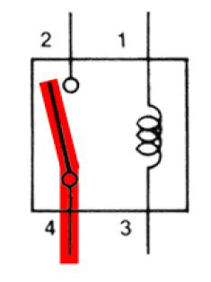
De-Energized Relay (OFF)
In simple, when a voltage is applied to pin 1, the electromagnet activates, causing a magnetic field to be developed, which goes on to close the pins 2 and 4 causing a closed circuit. When there is no voltage on pin 1, there will be no electromagnetic force and thus no magnetic field. Thus the switches remain open.

Pole and Throw
Relays have the exact working of a switch. So, the same concept is also applied. A relay is said to switch one or more poles. Each pole has contacts that can be thrown in mainly three ways. They are
- Normally Open Contact (NO): NO contact is also called a make contact. It closes the circuit when the relay is activated. It disconnects the circuit when the relay is inactive.
- Normally Closed Contact (NC): NC contact is also known as break contact. This is opposite to the NO contact. When the relay is activated, the circuit disconnects. When the relay is deactivated, the circuit connects.
- Change-over (CO) / Double-throw (DT) Contacts: This type of contacts are used to control two types of circuits. They are used to control a NO contact and also a NC contact with a common terminal. According to their type they are called by the names break before make and make before break contacts.
Relays can be used to control several circuits by just one signal. A relay switches one or more poles, each of whose contacts can be thrown by energizing the coil.
Relays are also named with designations like
- Single Pole Single Throw (SPST): The SPST relay has a total of four terminals. Out of these two terminals can be connected or disconnected. The other two terminals are needed for the coil to be connected.
- Single Pole Double Throw (SPDT): The SPDT relay has a total of five terminals. Out of these two are the coil terminals. A common terminal is also included which connects to either of two others.
- Double Pole Single Throw (DPST): The DPST relay has a total of six terminals. These terminals are further divided into two pairs. Thus they can act as two SPST which are actuated by a single coil. Out of the six terminals two of them are coil terminals.
- Double Pole Double Throw (DPDT): The DPDT relay is the biggest of all. It has mainly eight relay terminals. Out of these two rows are designed to be change over terminals. They are designed to act as two SPDT relays which are actuated by a single coil.

Relay Applications
- A relay circuit is used to realize logic functions. They play a very important role in providing safety critical logic.
- Relays are used to provide time delay functions. They are used to time the delay open and delay close of contacts.
- Relays are used to control high voltage circuits with the help of low voltage signals. Similarly they are used to control high current circuits with the help of low current signals.
- They are also used as protective relays. By this function all the faults during transmission and reception can be detected and isolated.

Application of Overload Relay
Overload relay is an electro-mechanical device that is used to safeguard motors from overloads and power failures. Overload relays are installed in motors to safeguard against sudden current spikes that may damage the motor. An overload relay switch works in characteristics with current over time and is different from circuit breakers and fuses, where a sudden trip is made to turn off the motor. The most widely used overload relay is the thermal overload relay where a bimetallic strip is used to turn off the motor. This strip is set to make contact with a contactor by bending itself with rising temperatures due to excess current flow. The contact between the strip and the contactor causes the contactor to de-energize and restricts the power to the motor, and thus turns it off.
Another type of overload motor is the electronic type which continuously watches the motor current, whereas the thermal overload relay shuts off the motor depending on the rise of temperature/heat of the strip.
All overload relays available to buy comes in different specifications, the most important of them being the current ranges and response time. Most of them are designed to automatically reset to work after the motor is turned back on.

Relay Selection
You must note some factors while selecting a particular relay. They are
- Protection Different protections like contact protection and coil protection must be noted. Contact protection helps in reducing arcing in circuits using inductors. Â Coil protection helps in reducing surge voltage produced during switching.
- Look for a standard relay with all regulatory approvals.
- Switching time Ask for high speed switching relays if you want one.
- Ratings There are current as well as voltage ratings. The current ratings vary from a few amperes to about 3000 amperes. Â In case of voltage ratings, they vary from 300 Volt AC to 600 Volt AC. There are also high voltage relays of about 15,000 Volts.
- Type of contact used whether it is a NC or NO or closed contact.
- Select Make before Break or Break before Make contacts wisely.
- Isolation between coil circuit and contacts

Bluetooth Module:

Introduction
- It is used for many applications like wireless headset, game controllers, wireless mouse, wireless keyboard and many more consumer applications.
- It has range up to <100m which depends upon transmitter and receiver, atmosphere, geographic & urban conditions.
- It is IEEE 802.15.1 standardized protocol, through which one can build wireless Personal Area Network (PAN). It uses frequency-hopping spread spectrum (FHSS) radio technology to send data over air.
- It uses serial communication to communicate with devices. It communicates with microcontroller using serial port (USART).

HC-05 Bluetooth Module
- HC-05 is a Bluetooth module which is designed for wireless communication. This module can be used in a master or slave configuration.
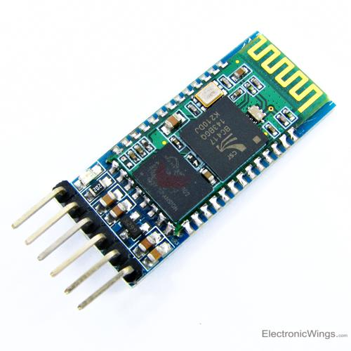
HC-05 Bluetooth Module
Pin Description
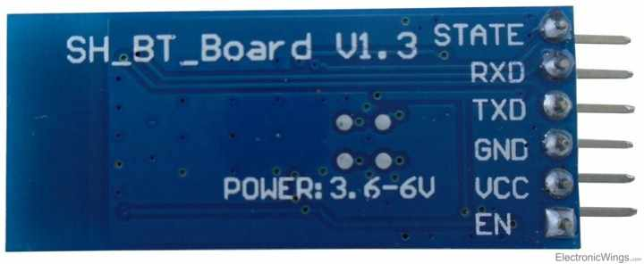
Bluetooth serial modules allow all serial enabled devices to communicate with each other using Bluetooth.
It has 6 pins,
1. Key/EN: It is used to bring Bluetooth module in AT commands mode. If Key/EN pin is set to high, then this module will work in command mode. Otherwise by default it is in data mode. The default baud rate of HC-05 in command mode is 38400bps and 9600 in data mode.
HC-05 module has two modes,
1. Data mode: Exchange of data between devices.
2. Command mode: It uses AT commands which are used to change setting of HC-05. To send these commands to module serial (USART) port is used.
2. VCC: Connect 5 V or 3.3 V to this Pin.
3. GND: Ground Pin of module.
4. TXD: Transmit Serial data (wirelessly received data by Bluetooth module transmitted out serially on TXD pin)
5. RXD: Receive data serially (received data will be transmitted wirelessly by Bluetooth module).
6. State: It tells whether module is connected or not.
HC-05 module Information
- HC-05 has red LED which indicates connection status, whether the Bluetooth is connected or not. Before connecting to HC-05 module this red LED blinks continuously in a periodic manner. When it gets connected to any other Bluetooth device, its blinking slows down to two seconds.
- This module works on 3.3 V. We can connect 5V supply voltage as well since the module has on board 5 to 3.3 V regulator.
- As HC-05 Bluetooth module has 3.3 V level for RX/TX and microcontroller can detect 3.3 V level, so, no need to shift transmit level of HC-05 module. But we need to shift the transmit voltage level from microcontroller to RX of HC-05 module.

Bluetooth communication between Devices
E.g., Send data from Smartphone terminal to HC-05 Bluetooth module and see this data on PC serial terminal and vice versa.
To communicate smartphone with HC-05 Bluetooth module, smartphone requires Bluetooth terminal application for transmitting and receiving data. You can find Bluetooth terminal applications for android and windows in respective app. store.
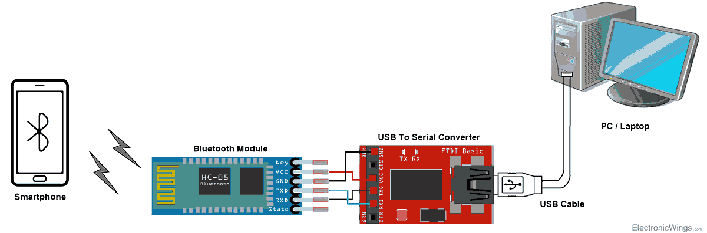
Bluetooth Module Serial Interface
So, when we want to communicate through smartphone with HC-05 Bluetooth module, connect this HC-05 module to the PC via serial to USB converter.
Before establishing communication between two Bluetooth devices, 1st we need to pair HC-05 module to smartphone for communication.
Pair HC-05 and smartphone:
- Search for new Bluetooth device from your phone. You will find Bluetooth device with “HC-05” name.
- Click on connect/pair device option; default pin for HC-05 is 1234 or 0000.
After pairing two Bluetooth devices, open terminal software (e.g. Teraterm, Realterm etc.) in PC, and select the port where we have connected USB to serial module. Also select default baud rate of 9600 bps.
In smart phone, open Bluetooth terminal application and connect to paired device HC-05.
It is simple to communicate, we just have to type in the Bluetooth terminal application of smartphone. Characters will get sent wirelessly to Bluetooth module HC-05. HC-05 will automatically transmit it serially to the PC, which will appear on terminal. Same way we can send data from PC to smartphone.

Command Mode
- When we want to change settings of HC-05 Bluetooth module like change password for connection, baud rate, Bluetooth device’s name etc.
- To do this, HC-05 has AT commands.
- To use HC-05 Bluetooth module in AT command mode, connect “Key” pin to High (VCC).
- Default Baud rate of HC-05 in command mode is 38400bps.
- Following are some AT command generally used to change setting of Bluetooth module.
- To send these commands, we have to connect HC-05 Bluetooth module to the PC via serial to USB converter and transmit this command through serial terminal of PC.
Command | Description | Response
AT | Checking communication | OK
AT+PSWD=XXXX | Set Password  e.g. AT+PSWD=4567 | OK
AT+NAME=XXXX | Set Bluetooth Device Name  e.g. AT+NAME=MyHC-05 | OK
AT+UART=Baud rate, stop bit, parity bit | Change Baud rate  e.g. AT+UART=9600,1,0 | OK
AT+VERSION? | Respond version no. of Bluetooth module | +Version: XX OK  e.g. +Version: 2.0 20130107 OK
AT+ORGL | Send detail of setting done by manufacturer | Parameters: device type, module mode, serial parameter, passkey,etc.

Battery:
A rechargeable battery is an energy storage device that can be charged again after being discharged by applying DC current to its terminals.
Rechargeable batteries allow for multiple usages from a cell, reducing waste and generally providing a better long-term investment in terms of dollars spent for usable device time. This is true even factoring in the higher purchase price of rechargeable and the requirement for a charger.
A rechargeable battery is generally a more sensible and sustainable replacement to one-time use batteries, which generate current through a chemical reaction in which a reactive anode is consumed. The anode in a rechargeable battery gets consumed as well but at a slower rate, allowing for many charges and discharges.
In use, rechargeable batteries are the same as conventional ones. However, after discharge the batteries are placed in a charger or, in the case of built-in batteries, an AC/DC adapter is connected.
While rechargeable batteries offer better long term cost and reduce waste, they do have a few cons. Many types of rechargeable cells created for consumer devices, including AA and AAA, C and D batteries, produce a lower voltage of 1.2v in contrast to the 1.5v of alkaline batteries. Though this lower voltage doesn't prevent correct operation in properly-designed electronics, it can mean a single charge does not last as long or offer the same power in a session. This is not the case, however, with lithium polymer and lithium ion batteries.
Some types of batteries such as nickel cadmium and nickel-metal hydride can develop a battery memory effect when only partially discharged, reducing performance of subsequent charges and thus battery life in a given device.
Rechargeable batteries are used in many applications such as cars, all manner of consumer electronics and even off-grid and supplemental facility power storage.
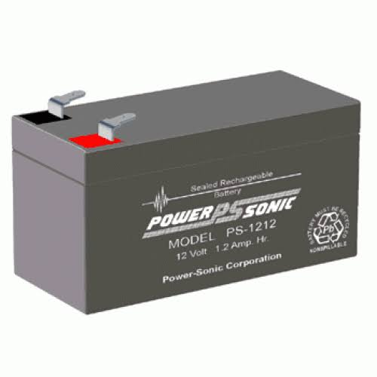

Switch:
A Push Button switch is a type of switch which consists of a simple electric mechanism or air switch mechanism to turn something on or off.
Depending on model they could operate with momentary or latching action function.
The button itself is usually constructed of a strong durable material such as metal or plastic. Push Button Switches come in a range of shapes and sizes. We have a selection of push button switches here at Herga.
Push button switches are used throughout industrial and medical applications and are also recognisable in everyday life.
For uses within the Industrial sector, push buttons are often part of a bigger system and are connected through a mechanical linkage. This means that when a button is pressed it can cause another button to release.
Push button switches are present in so many areas across different industries and for different uses here are some examples;
· Calculator buttons – a hand held calculator has lots of small push button switches
· Reset switches – these are usually small and require a tool to press to avoid accidental operation
· Stopping machinery – often around industrial machinery there will be an emergency stop button, sometimes these are located on the wall
· Arcade gaming – these are usually brightly coloured to encourage people to play

Features
Prevent flux rise by the insert-molded terminal
Snap-in mount terminal
Contact Bounce: MAX 5mS
Crisp clicking by tactile feedback
Dielectric Withstanding Voltage 250V AC for 1 minute

Technical Specifications
Mode of Operation: Tactile feedback
Power Rating: MAX 50mA 24V DC
Insulation Resistance: 100Mohm at 100v
Operating Force: 2.55±0.69 N
Contact Resistance: MAX 100mOhm
Operating Temperature Range: -20 to +70 ℃
Storage Temperature Range: -20 to +70 ℃

Where to use push button?
Push-Buttons are normally-open tactile switches. Push buttons allow us to power the circuit or make any particular connection only when we press the button. Simply, it makes the circuit connected when pressed and breaks when released. A push button is also used for triggering of the SCR by gate terminal. These are the most common buttons which we see in our daily life electronic equipment’s.

How to use a push button?
When connecting in between of supply and the circuit we should only connect the wires with both the legs of the Push-Button as shown in the circuit below:
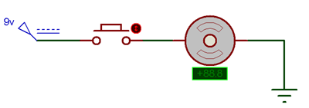
A Push-Button can also be used for the triggering purpose like of SCR. An SCR is a gate controlled Switch which needs a triggering pulse. So, for this we can add a Push button in the circuit to give a triggering pulse, as shown in the circuit below:
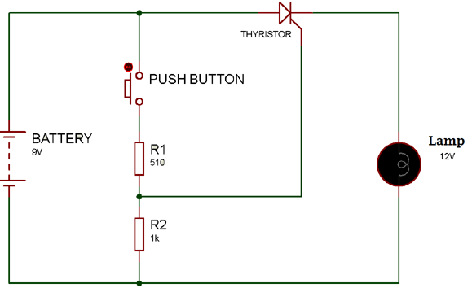
Power supply:
A power supply is a component that provides at least one electrical charge with power. It typically converts one type of electrical power to another, but it can also convert a different Energy form in electrical energy, such as solar, mechanical, or chemical.
A power supply provides electrical power to components. Usually the term refers to devices built into the powered component. Computer power supplies, for example, convert AC current to DC current and are generally located along with at least one fan at the back of the computer case.
Most computer power supplies also have an input voltage switch that, depending on the geographic location, can be set to 110v/115v or 220v/240v. Due to the different power voltages supplied by power outlets in different countries, this switch position is crucial.
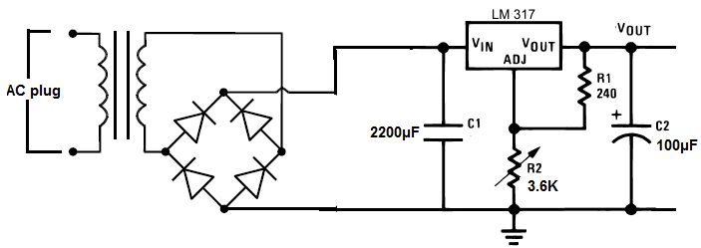
Some basic components used in the supply of power:
Transformer:
A transformer is a static electrical gadget that exchanges control between at least two circuits. A fluctuating current creates a changing attractive motion in one transformer curl, which thus actuates a differing electromotive power over a second loop twisted around a similar center.

Without a metallic association between the two circuits, electrical vitality can be exchanged between the two loops. The enlistment law of Faraday found in 1831 portrayed the impact of prompted voltage in any curl because of the changing attractive flux surrounded by the coil.
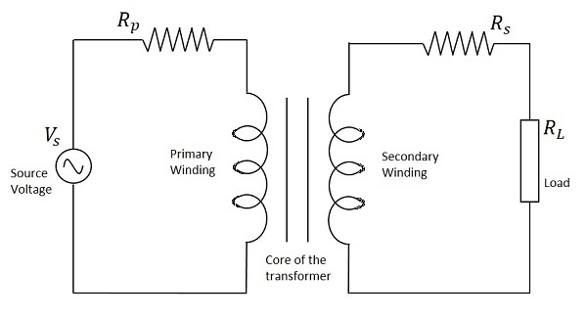
Circuit of transformer
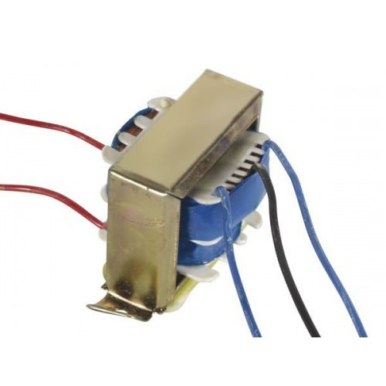
Transformer

Rectifier:
A rectifier is an electrical device that converts alternating current (AC), which periodically reverses direction, to direct current (DC), which flows in only one direction. The process is known as rectification, since it "straightens" the direction of current.
Rectifiers have many uses, but are often found to serve as components of DC power supplies and direct power transmission systems with high voltage. Rectification can be used in roles other than direct current generation for use as a power source.
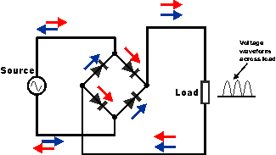
Circuit of rectifier
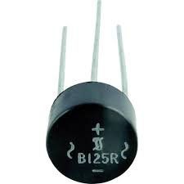
Rectifier

Capacitors:
Capacitors are used to attain from the connector the immaculate and smoothest DC voltage in which the rectifier is used to obtain throbbing DC voltage which is used as part of the light of the present identity. Capacitors are used to acquire square DC from the current AC experience of the current channels so that they can be used as a touch of parallel yield.
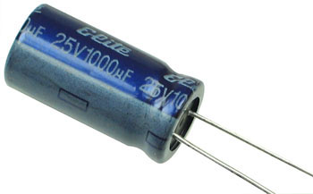
Capacitor

Voltage regulators:
The 78XX voltage controller is mainly used for voltage controllers as a whole. The XX speaks to the voltage delivered to the specific gadget by the voltage controller as the yield. 7805 will supply and control 5v yield voltage and 12v yield voltage will be created by 7812.
The voltage controllers are that their yield voltage as information requires no less than 2 volts. For example, 7805 as sources of information will require no less than 7V, and 7812, no less than 14 volts. This voltage is called Dropout Voltage, which should be given to voltage controllers.
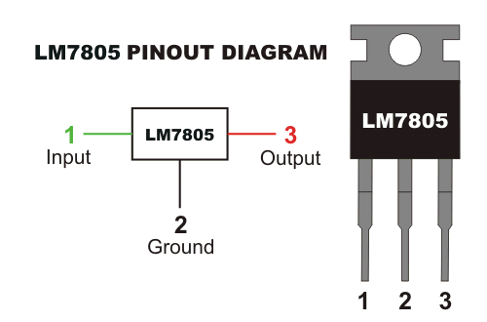

7805 voltage regulator with pinout
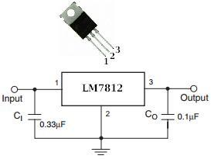
7812 voltage regulator with pinout

EMBEDDED C
Implanted C makes use of KEIL IDE programming. The framework program written in implanted C can be placed away in Microcontroller. The accompanying is a portion of the actual motives behind composing applications in C as opposed to get collectively. It is much less disturbing and much less tedious to write down in C then amassing. C is less traumatic to trade and refresh. You can utilize code available in capacity libraries. C code is compact to different microcontrollers with subsequent to 0 alteration. Genuine, installed C programming need nonstandard expansions to the C driver with a view to bolster charming components, as an example, settled point range catching, numerous unmistakable reminiscence banks, and fundamental I/O operations.
In 2008, the C Standards Committee prolonged the C data to deal with these problems via giving a normal well known to all executions to purchaser to contains numerous additives not handy in standard C, for example, settled factor wide variety catching, named address spaces, and vital I/O equipment tending to.
Installed C utilize the greater part of the grammar and semantics of wellknown C, e.G., number one() paintings, variable definition, facts type statement, contingent proclamations (if, switch. Case), circles (even as, for), capacities, exhibits and strings, structures and union, piece operations, macros, unions, and so on.
Embedded systems programming
Installed frameworks writing computer programs is not quite the same as creating applications on a desktop PCs. Key attributes of an implanted framework, when contrasted with PCs, are as per the following:
•Embedded gadgets have asset limitations (restricted ROM, constrained RAM, constrained stack space, less handling power)
•Components utilized as a part of installed framework and PCs are distinctive; implanted frameworks ordinarily utilizes littler, less power devouring segments. Inserted frameworks are more fixing to the equipment.
Two remarkable components of Embedded Programming are code speed and code estimate. Code speed is represented by the handling power, timing requirements, while code size is administered by accessible program memory and utilization of programming dialect. Objective of implanted framework writing computer programs is to get greatest elements in least space and least time.

Implanted frameworks are modified utilizing distinctive sort of dialects:
•Machine Code
•Low level dialect, i.e., get together
•High level dialect like C, C++, and Java and so on.
•Application level dialect like Visual Basic, scripts, Access, and so on..,
RASPBIAN
Raspbian is the recommended operating system for normal use on a Raspberry Pi.

Raspbian is a free operating system based on Debian, optimized for the Raspberry Pi hardware. Raspbian comes with over 35,000 packages; precompiled software bundled in a nice format for easy installation on your Raspberry Pi.

Raspbian is a community project under active development, with an emphasis on improving the stability and performance of as many Debian packages as possible.
Steps for installing Rasbian OS:
Step1: Download Raspbian

Step2: Unzip the file.
The Raspbian disc image is compressed, so you’ll need to unzip it. The file uses the ZIP64 format, so depending on how current your built-in utilities are, you need to use certain programs to unzip it. If you have any trouble, try these programs recommended by the Raspberry Pi Foundation:
- Windows users, you’ll want 7-Zip.
- Mac users, The Unarchiver is your best bet.
- Linux users will use the appropriately named Unzip.

Step3: Write the disc image to your micro SD card
Next, pop your micro SD card into your computer and write the disc imsage to it. You’ll need a specific program to do this:
- Windows users, your answer is Win32 Disk Imager.
- Mac users, you can use the disk utility that’s already on your machine.
- Linux people, Etcher – which also works on Mac and Windows – is what the Raspberry Pi Foundation recommends.
The process of actually writing the image will be slightly different across these programs, but it’s pretty self-explanatory no matter what you’re using. Each of these programs will have you select the destination (make sure you’ve picked your micro SD card!) and the disc image (the unzipped Raspbian file). Choose, double-check, and then hit the button to write.

Step4: Put the micro SD card in your Pi and boot up
Once the disc image has been written to the micro SD card, you’re ready to go! Put that sucker into your raspberry Pi, plug in the peripherals and power source, and enjoy. The current edition to Raspbian will boot directly to the desktop. Your default credentials are username pi and password raspberry.
Applications:
- Precision Fertilizer Application
- · Disease Monitoring and Management
- · Automated Crop Health Assessment
- · Sustainable and Eco-Friendly Farming
- · Remote Farm Monitoring and Control
Advantages:
- Reduces Human Labor and Intervention
- · Minimizes Fertilizer Wastage
- · Improves Crop Health and Yield
- · Supports Sustainable and Energy-Efficient Farming
- · Enables Real-Time Monitoring and Decision Making
Conclusion:
The Smart Fertilizer Spraying System with Plant Disease Severity Analysis presents an effective and innovative solution for modern precision agriculture. By integrating image-based plant disease severity detection with automated fertilizer spraying, the system ensures accurate and need-based application of fertilizers, thereby reducing wastage and improving crop health. The coordinated operation of the Raspberry Pi for image processing and the Arduino microcontroller for hardware control enables efficient robot movement and reliable system performance. The use of solar-assisted power enhances sustainability, while Bluetooth connectivity provides convenient wireless monitoring and control. Overall, this system minimizes human intervention, optimizes resource utilization, and supports eco-friendly farming practices, making it a promising approach for improving agricultural productivity and sustainability in real-world farming environments.
References…
- 1 Prakash M. Manikar, Shreekant Ghorpade, Mayur Adawadkar, "Plant Leaf Disease Detection and Classification Using Image Processing Techniques," International Engineering Journal, Volume 2, Issue 4, 2015.
- 2. 2 Prof. Bhavana Patil, Mr. Hemant Panchal, Mr. SHUBHAM Yadav, Mr. Arvind Singh, Mr. Dinesh Patil, "Plant Monitoring Using Image Processing, Raspberry PI and IOT," Journal of Engineering and Technology, Volume 4, Issue 10, 2017.
- 3. 3 Navin V. Dumare, Prof. S. S. Mungona, "Identification of Cotton Leaf Diseases Using Raspberry PI," Volume 5, Issue 5, 2017, International Journal on Recent and Technology Trends in Computing and Communication.
- 4. Prathamesh. K. Kharde, Hemangi. H. Kulkarni, "A Special Method for the Detection of Grape Leaf Diseases," International Journal of Scientific Research, Volume 2, Issue 4, 2016.
- 5. Jayaprakash Sethupathy, Veni S, International Journal of Engineering and Technology, Volume 8, No 5, 2016, "Open CV Based Disease Detection of Mango Leaves."

